

SWE 205: Introduction to Software Engineering

Term 191

**Software Implementation Document**

**Project:**

**Painting Software “MyPaintShop”**

**Group 11 Names:**

* ABDULLAH ALFAIFI
* FAWAZ ALESAYI (Leader)
* WALEED ALFAIFI
* YAZEED ALJOHANI

Table of Contents

1. Introduction 2

- **Introduction of the product:** 2

- **Technical Background** 2

- **Overview of the remainder of the document:** 2

2- Screenshots of the functionalities 3

a. Drawing shapes by dragging on the canvas 3

b. Selecting Colors and drawing the shape 3

c. Holding shift and drawing the alternative form of the shape 4

d. Selecting a shape 4

e. Changing a shape’s properties 4

f. Removing a shape 5

g. Duplicating a shape 5

h. Free drawing 6

i. Undoing changes 6

j. Saving the image 7

k. Loading the image 9

l. Shortcuts 10

Appendix 11

1. **Introduction**

- **Introduction of the product:**

This project is a drawing program which allows the user to draw shapes, change their color, export images, and load images.

This document showcases the implementation of the project by providing the source code, documentation (attached separately) and screenshots of the functionalities of the product.

- **Technical Background**

The product was developed using *Java*, specifically ***Java Development Kit version 1.8u231.***

It uses the JavaFX framework as basis for its user interface and model.

The GUI (Graphical User Interface) was built using GluonHQ’s SceneBuilder.

- **Overview of the remainder of the document:**

The only remaining section showcases some of the functionalities in pictures.

1. **Screenshots of the functionalities**
   1. **Drawing shapes by dragging on the canvas**

* 1. **Selecting Colors and drawing the shape**

* 1. **Holding shift and drawing the alternative form of the shape**

* 1. **Selecting a shape**

* 1. **Changing a shape’s properties**

* 1. **Removing a shape**

* 1. **Duplicating a shape**

* 1. **Free drawing**

* 1. **Undoing changes**

**Misplaced Red Rectangle**

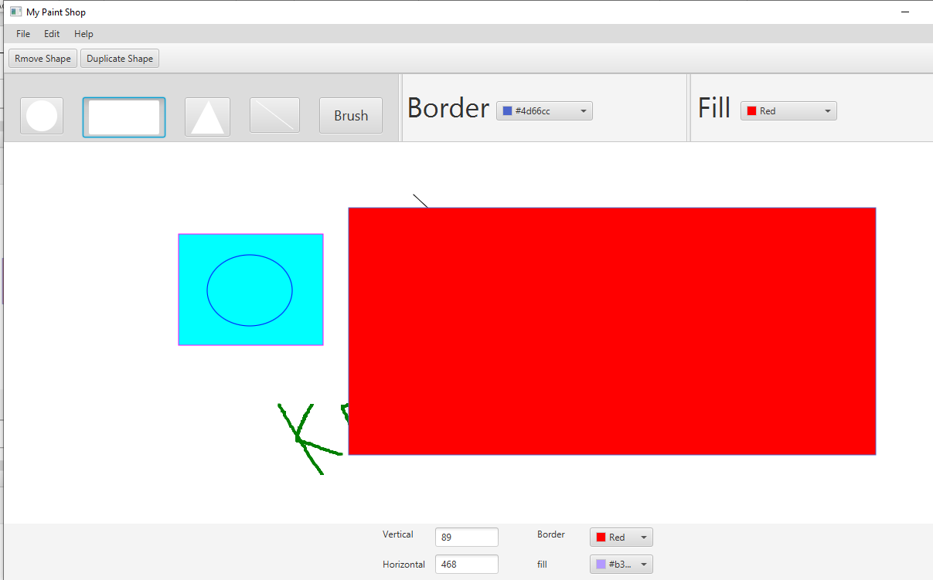

**After Undoing (Edit – Undo)**

* 1. **Saving the image**

**Sample drawing to be saved**

* 1. **Loading the image**

* 1. **Keyboard Shortcuts**

The application has many shortcuts for different functions

CTRL+N for making a new drawing

CTRL+S to save the current drawing

CTRL+O to open an image to draw on.

CTRL+Z for undo.

CTRL+C to copy a selected shape

DELETE to delete a selected shape

CTRL+V to paste a selected shape

CTRL+X to cut a selected shape

# **Appendix**

**The Group Meeting:**

1. **Wednesday, 4 Dec 2019**

the group had a meeting in 6:00 PM. The leader discussed with the team mates how the implementation should be and everyone got to work. We made the drawing logic before the meeting so we only had few features to implement. We wrote code and tried pair programming, and generally assisted each other. The meeting finished at 11:00 PM.

**Percentage of contribution of each member (Leader is in red)**

|  |  |
| --- | --- |
| Member | Percentage |
| Abdullah Alfaifi | **25%** |
| Fawaz Alesayi | **25%** |
| Waleed Alfaifi | **25%** |
| Yazeed Aljohany | **25%** |